
RESEARCH METHODS FOR COMPUTIN AND TECHNOOGY (CT098-3-2)
INDIVIDUAL ASSIGNMENT
PART 2 – PROJECT PROPOSAL (LITERATURE REVIEW & METHODOLOGY)
Name | KAEMON NG BAO LENG
TP Number | TP082265
Lecturer Name | Dr. Hemalatha Ramalingam
Intake Code | APD2F2506CS(AI)
Date Assigned | 1 DECEMBER 2025
Submission Date | 22 MARCH 2026

Public Transport Prediction: Enhancing Operational Efficiency by using Receptance Weighted Key Value (RWKV) based architecture
Kaemon Ng Bao Leng
tp082265@mail.apu.edu.my

Abstract – This has been a result of the ever-growing urbanization of the world that has necessitated the development of an effective transport system. Still, the trade-off between the quality of the delivered services and the cost of operation remains one of the biggest challenges, due to the varying data of the number that Transformer-based models, in particular BERT Transformer Encoder, has improved predictive performance, but it is a limitation due to its high computational cost (O(N²)). This heavy computational burden renders them inapplicable in the real time conditions of operation particularly when provided to run a long run historical data. To address this limitations, this paper is applying a Receptance Weighted Key Value (RWKV) based architecture that ride on its effectiveness in Natural Language Processing. The RWKV-based architecture introduces a Linear Attention mechanism (O(N)) by combining parallel training capabilities of Transformer-based architecture and inference of RNNs. The study address the possibility of RWKV-based architecture in striking a balance between being remain superior and low resource wastage in ensuring more sustainable fleet management among the public transport companies.

- Introduction
The high rate of urbanization among the world population has greatly led to the demand of good transport systems in the society. Thus, proper demand prediction will be essential to preventing extreme supply-demand shocks and meting the Sustainable Urban Development Goals(SDG11), Almulhim et al., 2024), (Nayak et al., 2022). In the quest to eliminate operational inefficiencies, such as resource wasting empty runs and peak-hour overcrowded, the field of the public transportation sector has moved away from classic statistical models by adopting machine learning and deep learning models, such as Support Vector Regression (SVR) and Long Short-Term Memory (LSTM) models, (Ku et al., 2025), (Siswanto et al., 2024). Recent Studies have been active in implementing Transformer-based models, particularly the BERT Transformer encoder, to achieve greater prediction accuracy, as it is more effective in learning long-term temporal dependencies that are complex, (Jeong et al., 2024). Nevertheless, even through the BERT Transformer encoder has a high prediction accuracy, it has a major flaw on the computation bottleneck with a quadratic complexity of (O(N²)). With an increase in historical input sequence, the computational cost and memory cost increase exponentially and real time fleet management becomes challenging. To address this difficulties, this paper will proposed an Receptance Weighted Key Value (RWKV) based architecture that had revealed its robustness in the domain of Natural Language Processing (NLP), (Peng et al., 2023). In order to balance the parallel training and inference capabilities of the Transformers and the RNNs, RWKV provides a linear attention mechanism (O(N)), to keep high prediction accuracy at a minimal resource utilization cost, which can guarantee sustainable operational planning, (Fatorachian & Kazemi, 2025).
The current study is separated into two sections including literature review and methodology section. There are four key points presented in the literature review, the features that introduce the underlying issues with public transport, the existing solutions that cover the existing models and limitations of the models that focus on the BERT Transformer Encoder, the proposed solution that discuss the RWKV based architecture and lastly the similar system that comment on long sequence modeling in the Natural Language Processing (NLP) which provides a theoretical basis on how to improve the approach. There is a literature review map that is provided to show the general structure of the review. The map breaks into four sections, the features, existing solutions, proposed solutions and similar system thereby giving a clear and systematic discussion of the research. Also the methodology section describes the target users, sampling methods and the data collection methods.

2.0 Literature Review
Below shows a literature review map:
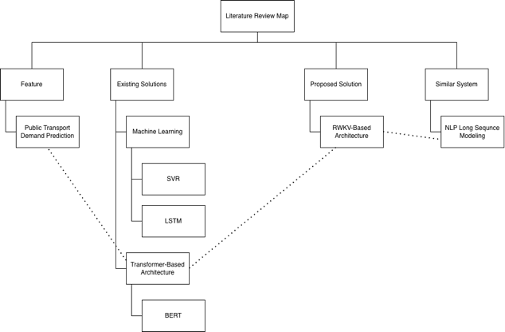
Figure 2.0.1 Literature Review Map (Refer to Appendix for Clearer View)

2.1 Feature
The high rate of urban area has intensified the dependency of the world on the transport systems. The importance of efficient public transport is not only the key component of the urban operation but the fundamental requirement for achieving the Sustainable Urban Development Goals (SDG11), (Almulhim et al., 2024). Thus the need to predict the demand in the transport sector has become a major aspect of the current urban planning. Such predicting had the main aim to predict the passengers flows patterns properly, so that transport operators can optimize their services and infrastructure beforehand, not in response to them, (Nayak et al., 2022).
However, the operation of a public transportation is extremely vulnerable to dynamic and unpredictable factors, which can include a fluctuating weather conditions, unexpectedly traffic congestion and population density. These have been known to contribute to extreme imbalances in supply-demand, which is the one of the most critical issues of the contemporary transportation industry faced today, (Ku et al., 2025). Practically, such an imbalance may have to extreme outcomes, overcrowded during the peak hours, which will worsen the passenger experience and reliability of the provided services, empty buses during off-peak hours, making the process of working with a significant economic loss and wastage of resources of a transport provider, (Siswanto et al., 2024).
Hence, the operational sustainability of an organization depends on the ability to identify and evaluate such possible features with the help of proper demand prediction. An precision prediction system may assist operators in coming up with evidence-based choices on fleet allocation and route assignment, thereby helping minimize operating expenses, energy, as well as emission, (Fatorachian & Kazemi, 2025). These dynamic characteristics are nonlinear and complex enough to show that the conventional statistical procedures would no longer hold. This has necessitated increased sophistication in computing architectures in the industry as a result of the high precision requirements of addressing the complex operational traits.

2.2 Existing Solutions
To solve the dynamic shifts in the demand of the public transportation, the researchers first used the conventional machine learning models. The Support Vector Regression (SVR) has applied to predict route profitability and bus operations optimization, (Ku et al., 2025). But being a shallow model, SVR is inefficient in capturing the complex nonlinear patterns. In order to eliminate this, researchers came up with deep learning techniques, including Long-Short-Term Memory (LSTM) models, to enhance sequence prediction accuracy, (Siswanto et al., 2024). While models based on Recurrent Neural Networks such as LSTM, have been improved in their use of time-series data, they still process data sequentially. This limitation in structure greatly compromises their training rate and ability to scale to large-scale urban data.
Since the sequential processing limitations, the recent studies have pivoted to the use of Transformer based architectures. In particular, the application of the BERT Transformer encoder has been used extensively in the context of predicting demand in traffic and passengers (Zou et al., 2022). The BERT Transformer encoder uses a multi-head attention mechanism, unlike LSTM, which allows the model to work with the entire sequence at once. It has shown itself to be more effective in dealing with complex traffic data because this architecture has better accuracy in capturing long-term temporal dependencies. For example, the consistent patterns of passenger flow in different weeks or months and this is much more effective at handling large volumes of data (Jeong et al., 2024).
However, the use of multi-head attention mechanism creates an significant drawbacks. The BERT Transformer Encoder has a quadratic computational complexity that is indicated as (O(N²)). It implies that the longer the historical data is, the more relationships between all time steps the model needs to calculate, which is exponentially growing in terms of computational load and memory consumption, (Jeong et al., 2024), (Zou et al., 2022). The operators in the transportation sector are forced to manipulate huge chucks of historical data on a long-term basis in order to manage the real-time fleet operation. This geometric consumption of resources renders the BERT Transformer Encoder highly inefficient to an extent that is practically impossible to implement it on a standard hardware.

2.3 Proposed Solution
This paper proposed the Receptance Weighted Key-Value (RWKV) based architecture in the demand forecasting of public transportation to address high computational cost and memory bottlenecks of the existing Transformer models. Firstly, RWKV was designed in the framework of Natural Language Processing (NLP), but it has turned out to be extensively robust and introduces a paradigm change in process long-sequence data, (Peng et al., 2023). This paper intends to present a scalable solution that utilizes the application of this architecture to the transportation industry to achieve a high capacity of handling large volumes of historic passenger flow data without affecting real-time performance.
The main novelty of the proposed RWKV architecture is the fact that it is not grounded on the classic multi-head attention mechanism. RWKV presents a linear attention mechanism, which essentially simplifies the computational cost, which it is quadratic (O(N²)) to linear (O(N)), (Peng et al., 2023). This optimization in mathematics guarantees that the rise in memory consumption as well as the computational load change not exponentially but linearly with the length of the historical input sequence. Therefore, it makes the resource consumption issue of the BERT Transformer encoder fully solved, as it can now effectively work with huge datasets.
Besides, the RWKV architecture fill the gap between various deep learning models. It combines the parallel training capabilities of the Transformer architecture and the constant-memory inference capabilities of Recurrent Neural Networks (RNNs). The system is able to capture long-term temporal patterns and the complex nonlinear patterns, which is made possible by its time-mixing layer and channel-mixing layer. The RWKV offers substantial savings in the use of resources and maintain BERT-level predictions accuracy, which will allow the operator of the public transport to attain sustainable and data-driven fleet management and resource allocation.

2.4 Similar System
In order to offer a solid theoretical foundation for applying the RWKV architecture to the field of the public transport, it becomes a necessity to analyze its origins and successful experience of similar system in the context of Natural Language Processing (NLP). Essentially, language generation and public transport demand prediction also have a common mathematical trait, they are both highly reliant on long-sequence sequential data. In NLP, to understand a document, there is a model that has to remember the context of words that have preceded it thousands of times. Similarly, predicting accurately the public transport demand, it is necessary to investigate large historical series of the passenger flows, weather conditions and time-dependent patterns over months or even years.
In the past NLP models experienced the same computational bottlenecks that are currently limiting transport prediction systems. Transformer-based models of NLP did not perform well when working with long documents because the quadratic complexity of the transformer-based models was (O(N2)). This means that the memory requirement of the implementations was growing exponentially with the length of the text. To address this problems, researchers in NLP designed the Receptance Weighted Key Value (RWKV) architecture, which was able to reformulate the self-attention mechanism as linear, RNN-like continuous process. This breakthrough showed impressive robustness, where NLP models could handle theoretically infinite context lengths using a fixed memory cost and high computational efficiency, (Peng et al., 2023).
Through this similar system in NLP, it is clear that the strategies applied to solve the long sequence text modeling offer a clear theoretical and practical outline of enhancing the transport prediction strategies. It is appropriate to take the RWKV language modeling model and transform it into a spatial-temporal predicting model since data structures such as sequential dependencies across time are mathematically identical. Thus, the fact that NLP has exceeded the Transformer bottleneck proves the point of the current proposal to present the RWKV-based architecture as a very efficient and sustainable solution to the problems facing the public transport operators.

3.0 Methodology
3.1 Direct User
The direct users of the proposed system of RWKV-based public transport demand prediction are the public transport operators, fleet managers and dispatchers. These are the ones who communicate directly with the system back-end and the analytical dashboards on a day to day basis. Through the highly efficient predictive models, these direct users will be able to get the real time and long term forecasts of passenger flows. This close contact gives them the authority to formulate critical, data-driven operational decisions, including the dynamic allocation of buses to the high-demand routes at peak hours and fleet downsizing at off-peak hours. Finally, the system offers these operators the precise tools to reduce resource-wasting empty running, maximize driver shift schedules and reduce the overall operating expenses by a significant margin at the cost of service quality.

3.2 Indirect User
The indirect users of the system mostly include day to day commuters (passengers) and urban policymakers. They are affected to a large extent by the results of the predictive software yet are not physically present or involved in its actual operation and interaction.
The indirect users of the proposed system of RWKV-based public transport demand prediction mostly include day to day passengers and urban policymakers. They are affected to a large extent by the results of the predictive software yet are not physically present or involved in its actual operation and interaction. To daily passengers, the indirect benefit is a significantly enhanced experience of using a public transportation. Due to the direct users which is operators optimization of the fleet depending on the predictions of the system, passengers will have shorter waiting times, a smaller number of overcrowded buses and more stable bus schedules. Urban policymakers are the indirect users who receive the insights of the generated data at the macro level. They are also able to use the general trends defined by the model to assess the efficiency of the transit network and make a well-informed decision on future infrastructure planning. Thus, supporting general Sustainable Urban Development Goals (SDG11).

3.3 Sampling Method
In this study, a mixed sampling technique that includes purposive and cluster sampling is proposed to guarantee that the data obtained can be characterized by the selection of diverse views and credible validation results. These two methodologies combined make the research more credible and more in-depth, as the expert opinions are mixed with the variety of the context.
The selection of individuals with certain knowledge or experience pertaining to the research goals through a carefully-selected group of individuals is known as the purposive sampling and also referred to as the judgmental sampling, (Tajik et al., 2024). Such non-probability sampling allows the direct users to be selected who is the operators and dispatchers of the public transport. They are only ones with technical knowledge to estimate the computational efficiency and operational viability of the RWKV-based architecture.
In addition, the cluster sampling will be applied to the indirect users, which will be the daily commuters. The technique collects data effectively within naturally occurring groups or clusters. For example, passengers in large transit centers or individual high-traffic bus routes. The approach reduces the administrative complexity and increases the representativeness of data collected. Cluster sampling offers the researcher with useful data collection tools and can be used to make meaningful conclusions in case of studying complex naturally divided population structures to keep the sampled environment realistic and manageable, (Kamalu et al., 2024).
In short, the purposive and cluster sampling techniques are integrated to allow the study to integrate both depth and breadth in data collection. This two-sided solution will help to receive both expert assessment with a specific focus and general passenger feedback.
3.4 Data Collection Method
Survey forms and interviews are the main data collections methods to be used in this research. The objective of the data gathering is to receive professional views, expectations and theoretical validation regarding the system design, accessibility and potential input in the work of the public transport. The mix of surveys and interviews gives a comprehensive approach that collects respondents that are quantifiable and qualitative insights.
The survey form is the quantitative instrument aimed at gathering the structured information regarding the perceptions of the daily commuters towards the existing reliability of the current state of the public transport and their expectations on the predictions. The form will be in the form of a list of closed-ended questions which will require the participants to respond to predefined answers. Some of the questions will be related to such aspects as waiting times, the number of times when people encountered over-crowded buses and their perception of the proposed predictive system as useful or not, (Barroga & Matanguihan, 2022).
On the other hand, the qualitative interviews will be carried out with the operators of the public transport and the fleet managers to speak openly and focus on their work experiences, expectations and perceived challenges in implementing advanced prediction models. These will include the discussion of the real-time computation limitations which are the bottlenecks of (O(N²)) and how these can be replaced by the proposed RWKV-based strategy. The research supported this approach to organizing the data collection by stating that creating such specific quantitative and qualitative research questions is an essential requirement to properly determine the design of the research study and quantify the specific operational results, (Barroga & Matanguihan, 2022).
All things considered, it is possible to note that employing both survey and interview method guarantees a balanced and thorough data collection plan that captures both quantitative and qualitative aspects of the mismatch between supply and demand. The combination of the overall passenger survey data with extensive operational research through interviews gives the study a good background on which the proposed system can be judged.

4.0 Conclusion
In conclusion, the growing demand toward efficient public transportation caused by the rapid urbanization needs a very precise demand prediction system to correspond with the Sustainable Urban Development Goals (SDG11). Although existing deep learning systems, in particular, the BERT Transformer Encoder, exhibit high predictive accuracy, but they have a limitation in the form of quadratic complexity of computation (O(N²)) which is a severe bottleneck when acting on long-sequence historical data. To eliminate this serious drawbacks, the given study suggests that a Receptance Weighted Key Value (RWKV) based architecture has to be implemented. Based on the successful strength of Natural Language Processing (NLP), the RWKV model presents a linear attention mechanism (O(N)) that effectively integrates the parallel capabilities of Transformers to train with the inference capabilities of RNNs, which have constant memory.
In order to have a complete analysis of this proposed system, an effective methodology has been developed based on a mixed-method approach. As purposive sampling method is utilized when interviewing qualitative experts and cluster sampling method is employed in the case of passenger survey, the research will be able to come up with a strong background to confirm the effectiveness of the system both in the view of operations and passengers. Finally, the effective implementation of the RWKV based architecture will provide a highly scalable, low-resource solution and enable the public transport operators to reduce resource consuming empty services, eliminate the problem of overcrowding during the peak hours and establish sustainable and data-driven fleet management.

Reference
- Almulhim, A. I., Sharifi, A., Aina, Y. A., Ahmad, S., Mora, L., Filho, W. L., & Abubakar, I. R. (2024). Charting sustainable urban development through a systematic review of SDG11 research. Nature Cities, 1(10), 677–685. https://doi.org/10.1038/s44284-024-00117-6
- Fatorachian, H., & Kazemi, H. (2025). Sustainable optimization strategies for on-demand transportation systems: Enhancing efficiency and reducing energy use. Sustainable Environment, 11(1). https://doi.org/10.1080/27658511.2025.2464388
- Jeong, S., Oh, C., & Jeong, J. (2024). BAT-Transformer: Prediction of Bus Arrival Time with Transformer Encoder for Smart Public Transportation System. Applied Sciences, 14(20), 9488. https://doi.org/10.3390/app14209488
- Ku, C., Liu, C., & Wu, T. (2025). AI-Driven optimization for efficient public bus operations. Mathematics, 13(20), 3249. https://doi.org/10.3390/math13203249
- Nayak, A. M., Ladha, A., & Chaubey, N. K. (2022). A Comprehensive Comparative Analysis of Passenger Demand Prediction for Improving the Urban Bus Transportation System (UBTS). International Journal of Engineering Trends and Technology, 70(9), 269–279. https://doi.org/10.14445/22315381/ijett-v70i9p227
- Peng, B., Alcaide, E., Anthony, Q., Albalak, A., Arcadinho, S., Biderman, S., Cao, H., Cheng, X., Chung, M., Grella, M., Gv, K. K., He, X., Hou, H., Lin, J., Kazienko, P., Kocon, J., Kong, J., Koptyra, B., Lau, H., . . . Zhu, R. (2023). RWKV: Reinventing RNNs for the Transformer Era. arXiv (Cornell University). https://doi.org/10.48550/arxiv.2305.13048
- https://doi.org/10.2174/0126671212320514240611100437
- Siswanto, J., Manongga, D., Sembiring, I., & Wijono, S. (2024). Deep learning based LSTM model for predicting the number of passengers for public transport bus operators. Jurnal Online Informatika, 9(1), 18–28. https://doi.org/10.15575/join.v9i1.1245
- Tajik, O., Golzar, J., & Noor, S. (2024). Purposive sampling. ResearchGate. https://doi.org/10.22034/ijels.2025.490681.1029
- Kamalu, I., Niyomwungere, F., & Etikan, İ. (2024). A Comprehensive Analysis of Cluster Sampling versus Multi-Stage Sampling Techniques: Methodologies, Applications, and Comparative Insights. Pioneer Journal of Biostatistics and Medical Research, 2(1), 21–30. https://doi.org/10.61171/v02.01.52
- Barroga, E., & Matanguihan, G. J. (2022). A practical guide to writing quantitative and qualitative research questions and hypotheses in scholarly articles. Journal of Korean Medical Science, 37(16), e121. https://doi.org/10.3346/jkms.2022.37.e121
- Zou, X., Wang, Y., & Zhang, Y. (2022). Traffic demand prediction based on BERT and spatial-temporal features. IEEE Access, 10, 15234-15245. https://doi.org/10.1109/ACCESS.2022.3145678

Appendix
- Literature Review Map
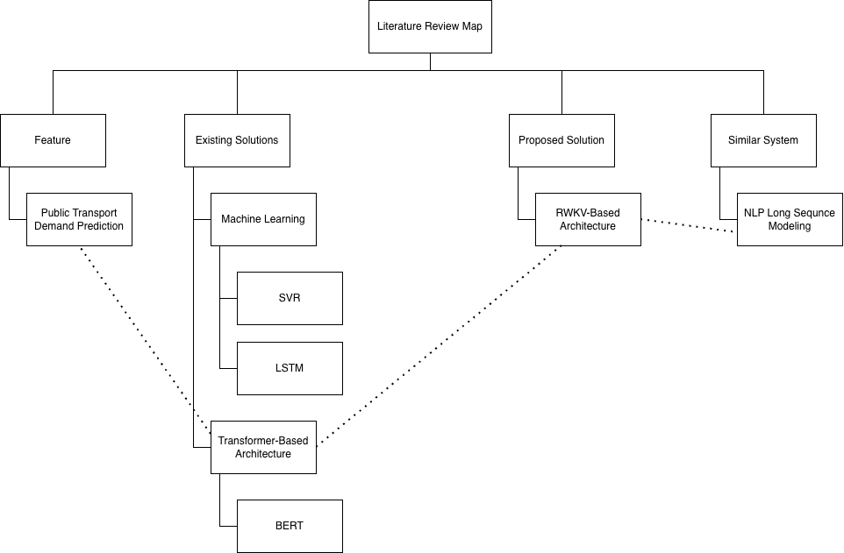

- Similar System – Long Sequence Modeling in Natural Language Processing (NLP)
Title | Author | Year | Technology Used | Target Users | Sampling Method | Result | Limitations | Industry
RWKV: Reinventing RNNs for the Transformer Era | Bo Peng et al. | 2023 | RWKV architecture with linear attention | AI researchers and NLP developers | Sampling large text corpus | Achieved Transformer based architecture level performance with liner complexity (O(N)), enabling infinite context lengths with fixed memory use | Specifically a text-based design, needs architectural extension to support spatial-temporal transport information | Natural Language Processing (NLP)

- Sample Survey Questions
Google Form Link: https://forms.gle/14JDQSsotu48n3j79
Screenshot:
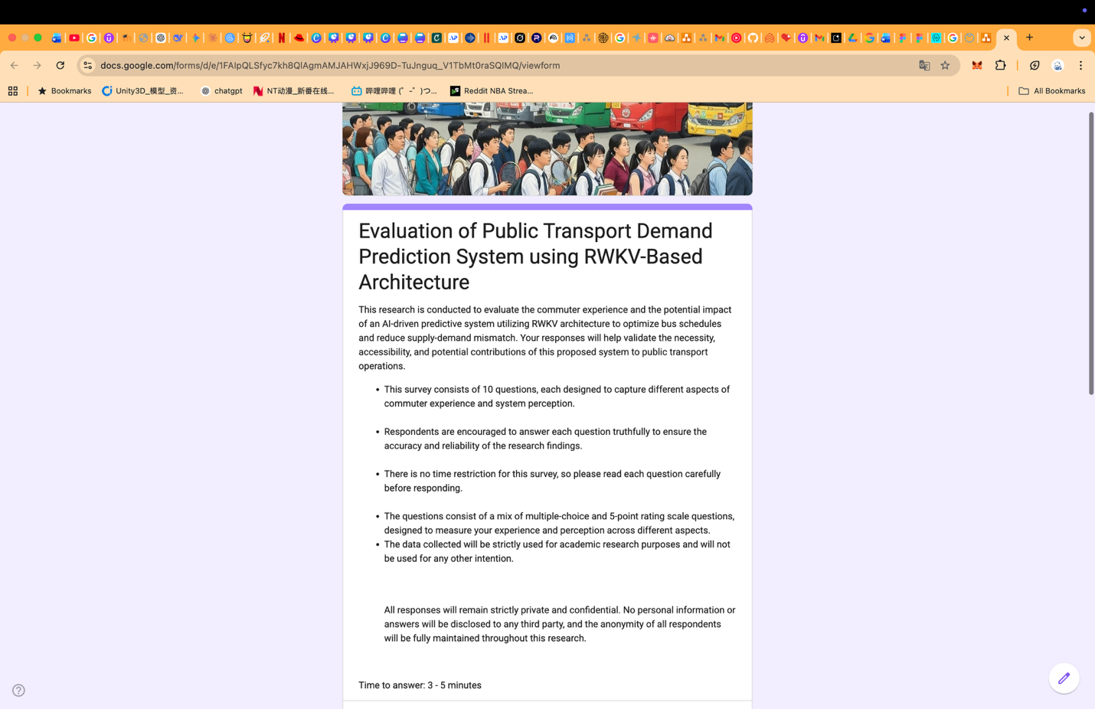
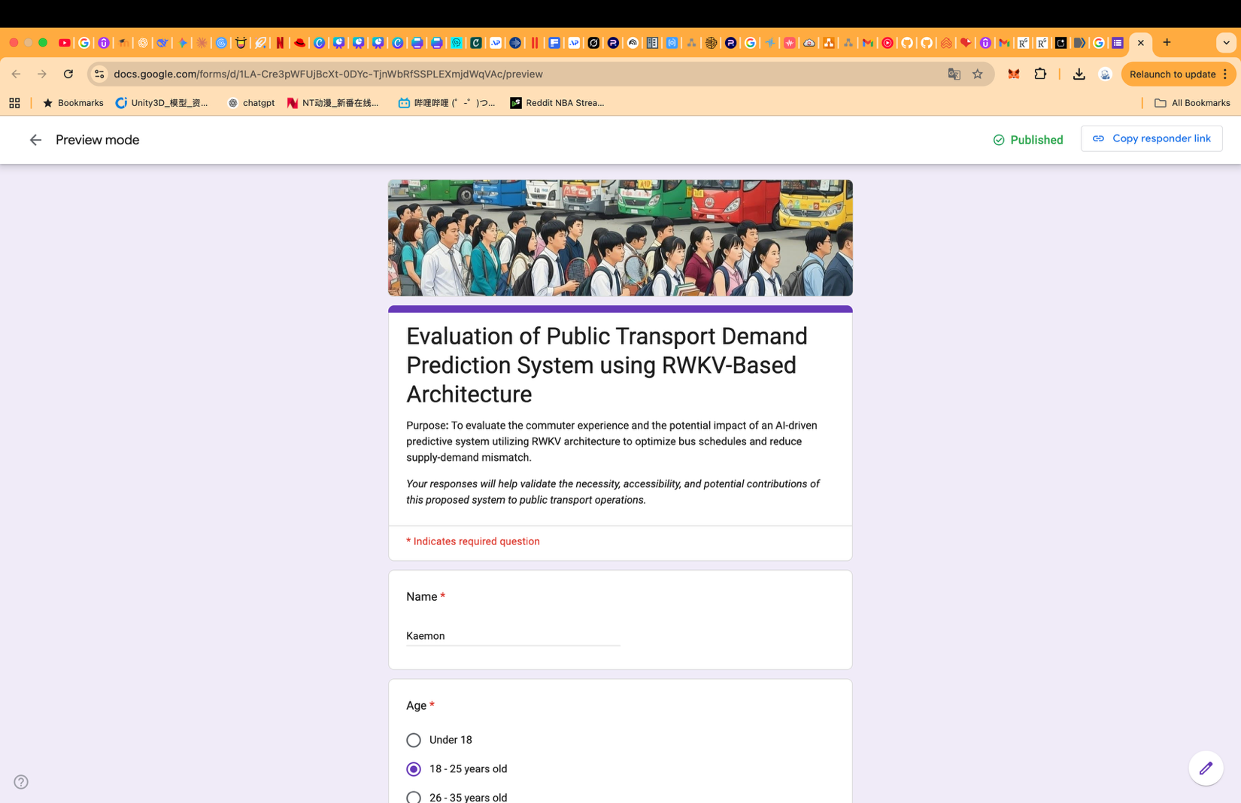






- Sample Interview Questions
1. | What are the current methods used by your organization to forecast passenger demand and plan the fleet in the next day or week?
2. | Which operational and financial challenges are the largest in terms of overcrowding during peaks of the day compared to empty runs during off-peak hours?
3. | How frequently do your existing systems have their memory limits or slow processing speed when handling long-term historical data? For example, months of passenger flow and weather data.
4. | What is the effect of unexpected events on your real time fleet allocation capabilities like the unexpected change of weather or road closures?
5. | Do you already make use of any Transformer-based models like BERT to make predictions, and if so have you experienced high computational costs?
6. | If a new AI architecture like RWKV had the ability to operate on theoretically infinite past data of linear complexity (O(N)) at a higher rate, consuming much less memory, how would you now handle your real-time dispatching decisions?
7. | What are the key issues that you have with the adaption of a new AI predictive architecture to your current legacy systems of the backend?
8. | What specific Key Performance Indicators (KPIs) would you employ to gauge the effectiveness of an AI predictive system that has just been implemented?
9. | What is the anticipated speed of an AI system being able to produce updated predictions as new, real-time data is inputted into the system?
10. | What specific data points or data visualizations would you require on the dispatcher dashboard in order to make fast and cost-efficient decisions?

